**Topics:** Elastic Beanstalk [Deployment topic] [non recommended for big Enterprise, large companies]

**Elastic Beanstalk: PAAS**

AWS Elastic Beanstalk is an easy-to-use service for deploying and scaling web applications and services. For example, we deploy a java web application on Apache Tomcat sever.

EBS is powered by CloudFormation template setup.

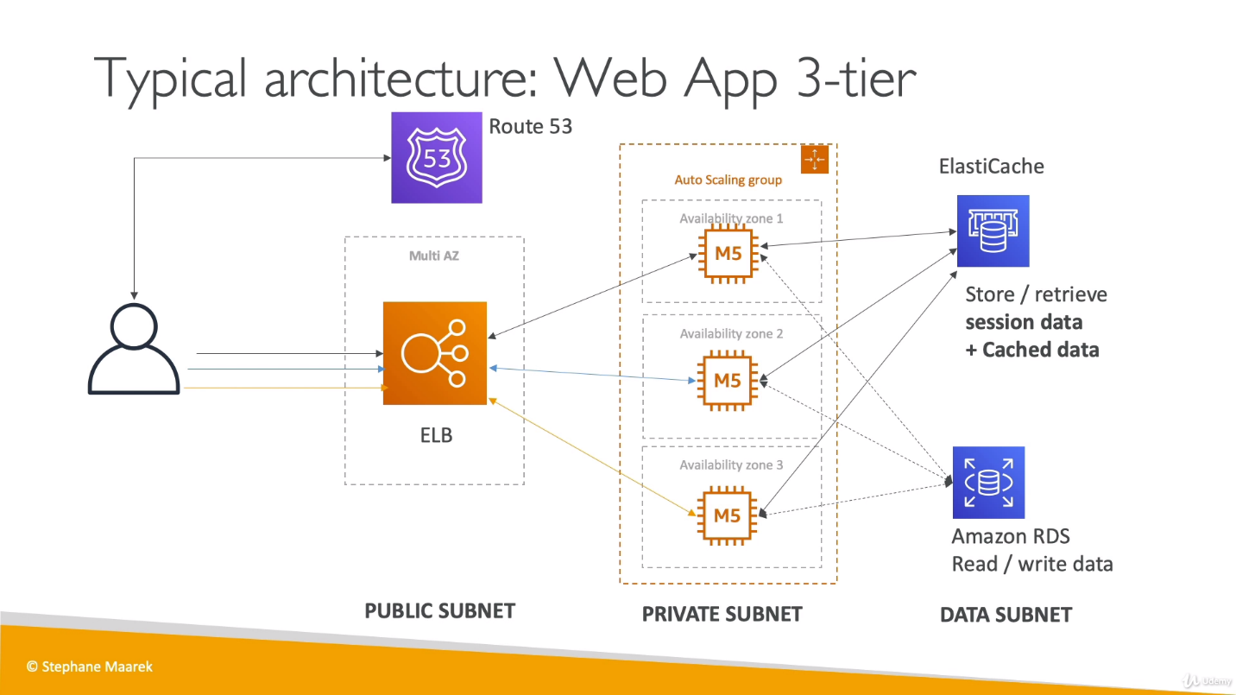

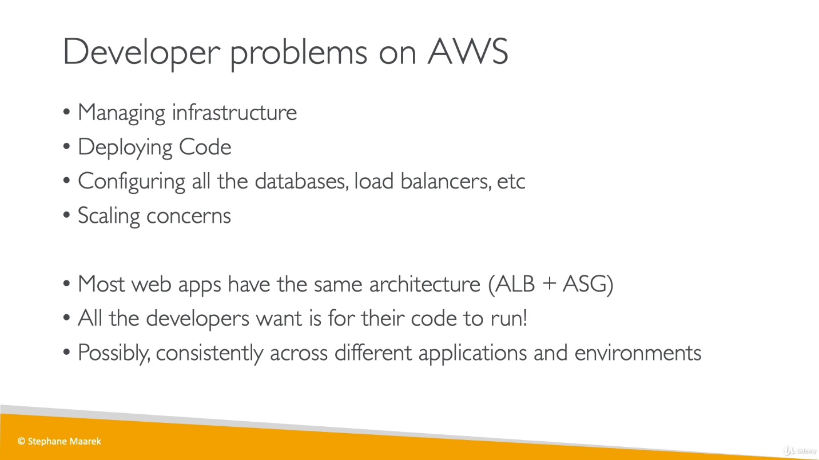

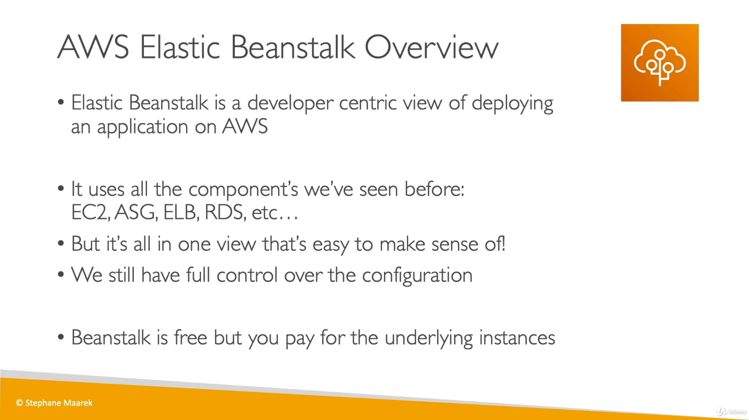

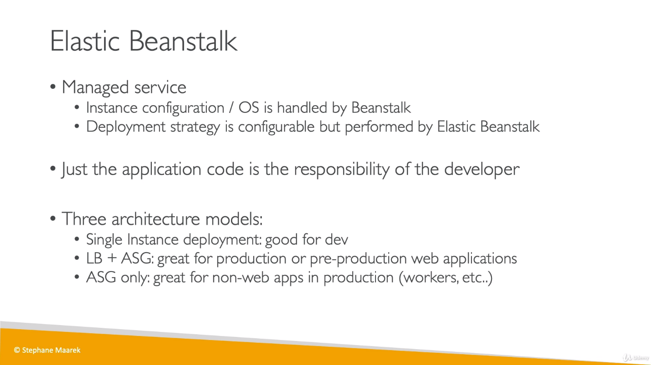

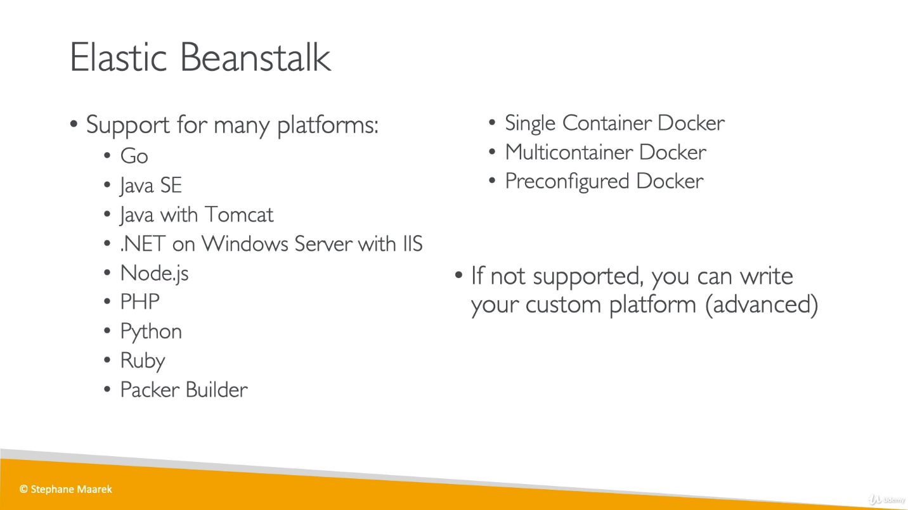

Single container: One EC2 instance, good for dev work.

Multi container : Multiple EC2 instances.

Preconfigured container : There will preconfigured setup to run a program written in any of given languages. Like if we have program written in Java, we don’t need to take care of JVM,JRE etc.

We can choose any of our mentioned platform and as soon as the we create environment for this platform, we will get a URL and if we check on this URL, it will show that your (*chosen platform) application is running.

We can create docker environments that support multiple containers per Amazon EC2 instance with multicontainer Docker platform for Elastic Beanstalk.

**Elastic Beanstalk uses Amazon Elastic Container Service (Amazon ECS)** to coordinate container deployments to multicontainer Docker environments. Amazon ECS provides tools to manage a cluster of instances running Docker containers. Elastic Beanstalk takes care of Amazon ECS tasks including cluster creation, task definition and execution.

Some regions don't offer Amazon ECS. Multicontainer Docker environments aren't supported in these regions.

So, by doing this, it has created an application and under that an environment. For ex: [my-first-webapp-beanstalk](https://ap-south-1.console.aws.amazon.com/elasticbeanstalk/home?region=ap-south-1#/application/overview?applicationName=my-first-webapp-beanstalk) is application name and [MyFirstWebappBeanstalk-env](https://ap-south-1.console.aws.amazon.com/elasticbeanstalk/home?region=ap-south-1#/environment/dashboard?applicationName=my-first-webapp-beanstalk&environmentId=e-b2bfwaxz8u) is environment name.

**In Environment:**

We can choose Events from options available left side for this environment, and choose severity, we will get all details/logs what had happened based on severity (as info, error, debug etc.)

From info, we can see that:

* An AWS S3 bucket was created to store the environment data.
* An EC2 instance was created along with security group and an Elastic IP (which has been assigned to EC2 instance).

If we define an RDS DB in Beanstalk, DB will be deleted once we delete the environment.

We can’t modify Load Balancer for entire life cycle of environment once chosen. So, if we chose Application LB then can’t be switched to Classic LB.

We can create another environment (either web server environment or worker environment) under the same Application.

So, we have created another environment ex “[MyFirstWebappBeanstalk-prod](https://ap-south-1.console.aws.amazon.com/elasticbeanstalk/home?region=ap-south-1#/environment/dashboard?applicationName=my-first-webapp-beanstalk&environmentId=e-ygn4gpjidh)” under the same application and this time we chose to use ALB and under Modify Capacity, we chose Max instance as for Auto Scaling group. Now a new EC2 instance would be created but this time it will not have Elastic IP, because we are using ALB.

If we see Auto Scaling group for this, there are 2 scaling policies have been created, one for scale up and another for scale down (To increase/decrease no of EC2 instances).

If we see the security group, there are 3 entries, one for first EC2 instance for first environment, second for second EC2 instance of second environment which is accepting traffic only from ALB and third for ALB.

**Elastic Beanstalk Deployment Modes: **imp\*\***

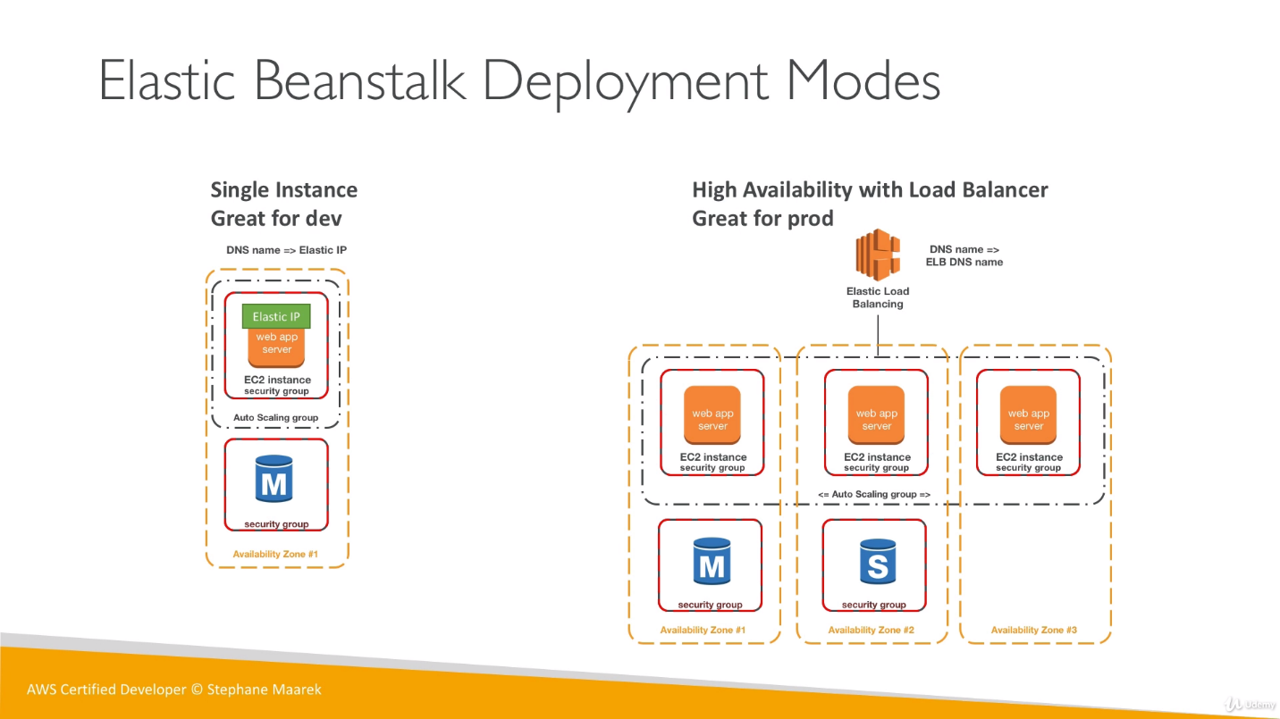

Web vs Worker Env:

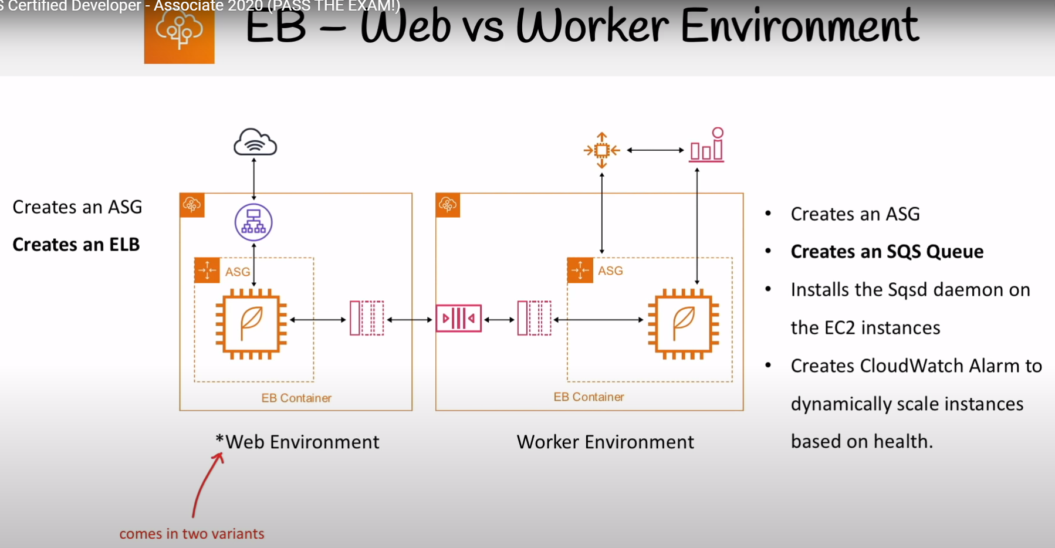

Web env variants:

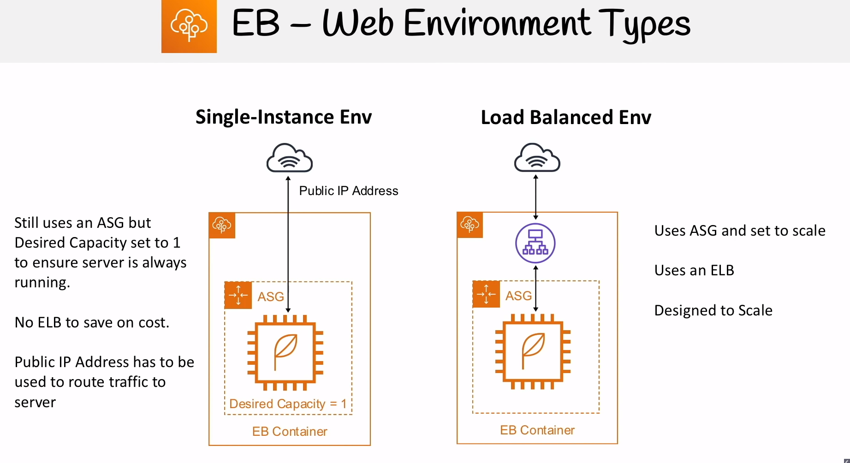

**Elastic Beanstalk Deployment Options:**   
We are deploying single application which might be having multiple instances. In all below examples we took an application having 4 isntances.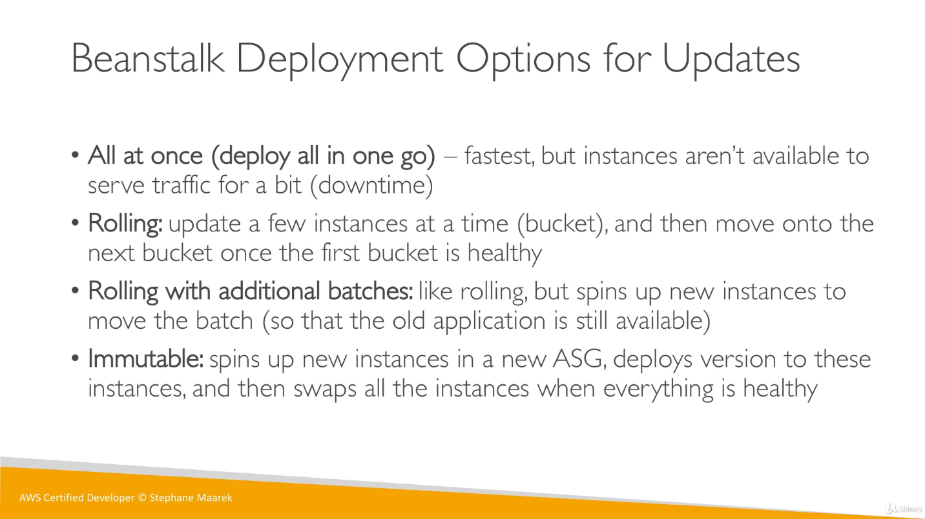

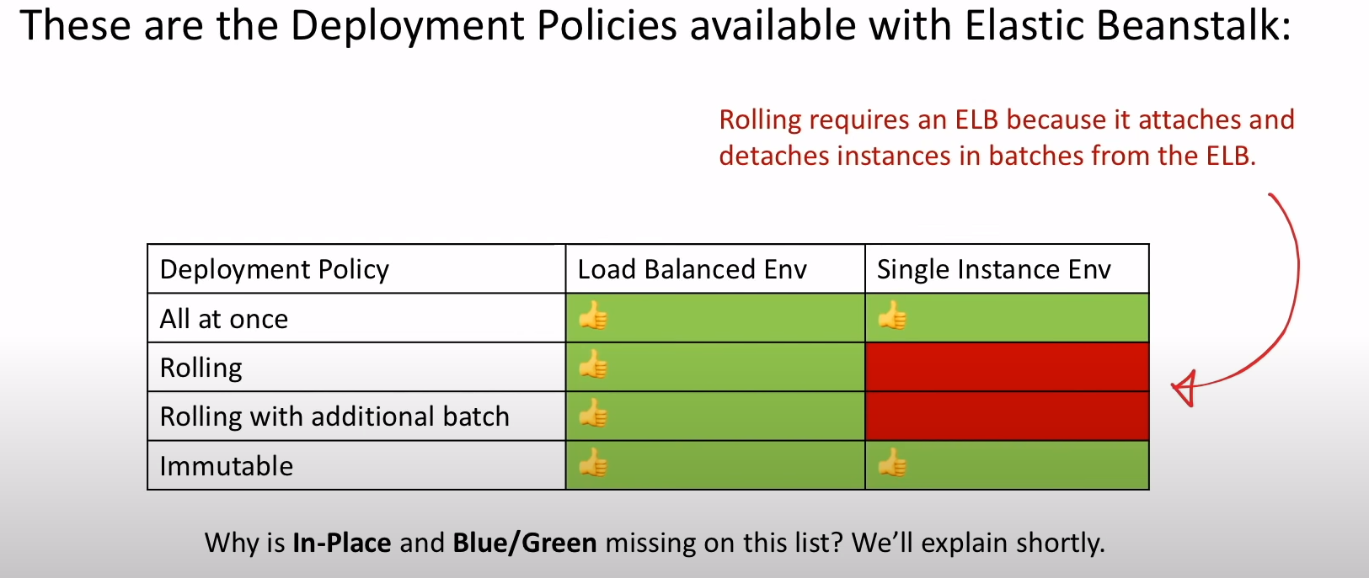

1. **All at once:**

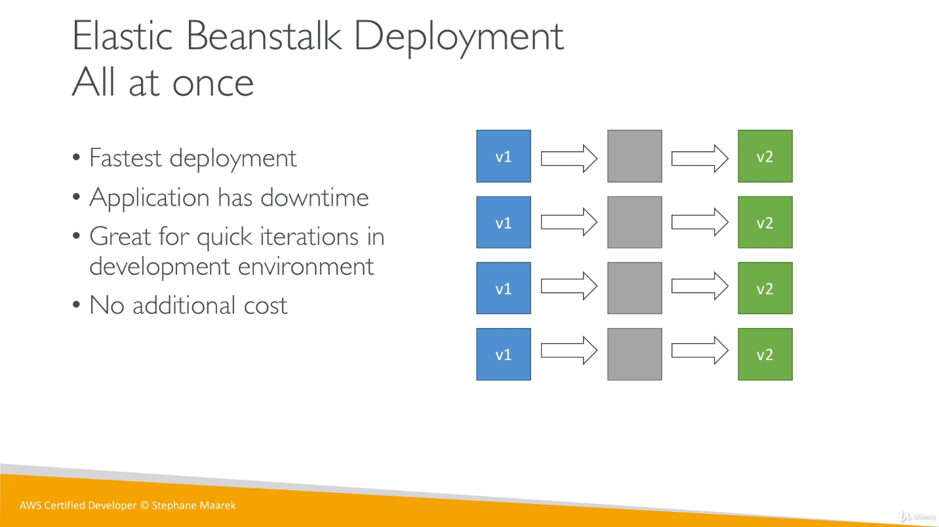

1. **Rolling**

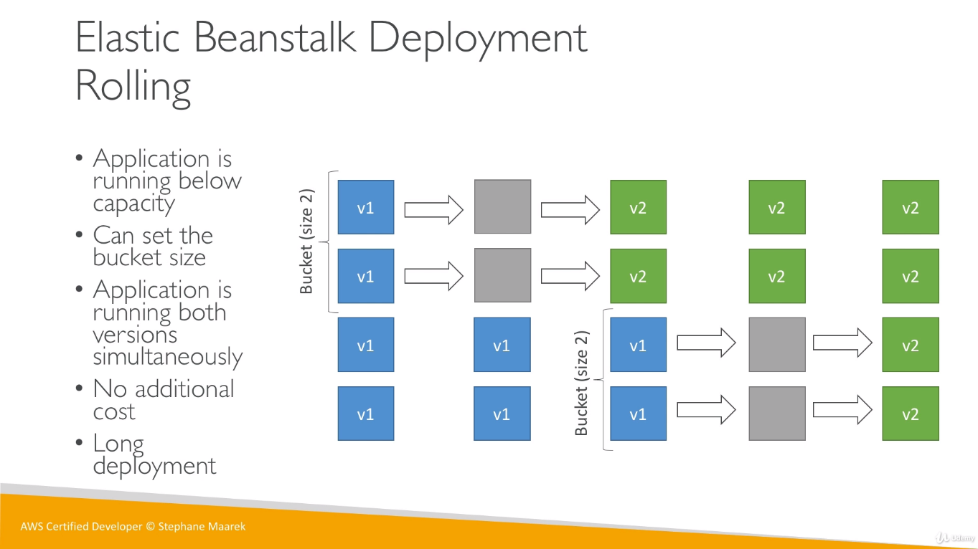

Suppose we have 100 instances in our application, and we have setup bucket size 2, then it will down 2 instance each time and update them so it will be time consuming.

1. **Rolling with Additional Batches:**

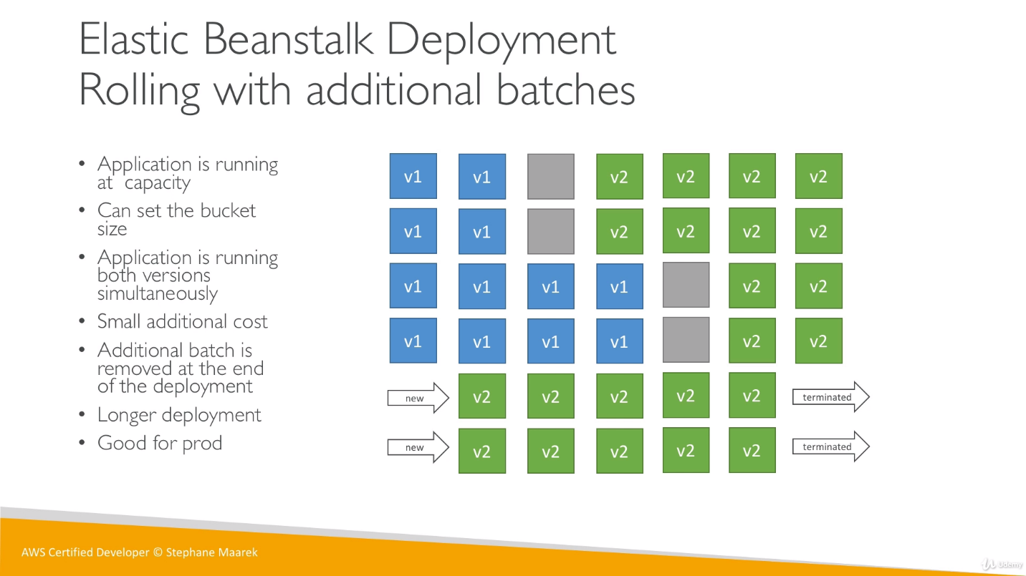

Here we have a batch, which will add additional capacity (define 2 in batch) by increasing 2 new instances for the application. We have 6 instances this time so now 2 instances will be replaced by v2 same will happen with rest of the instances and at last batch will terminate the additional instances.

1. **Immutable:** worked with ASG. Extra ASG [safest way to deploy critical app] In-Place (because ASG is changing within the same env)

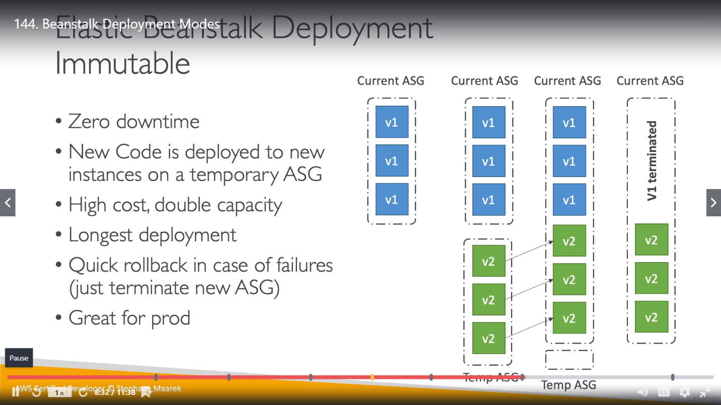

1. **Blue/Green Deployment:** Extra Env, not In-Place as we are using 2 env in deployment

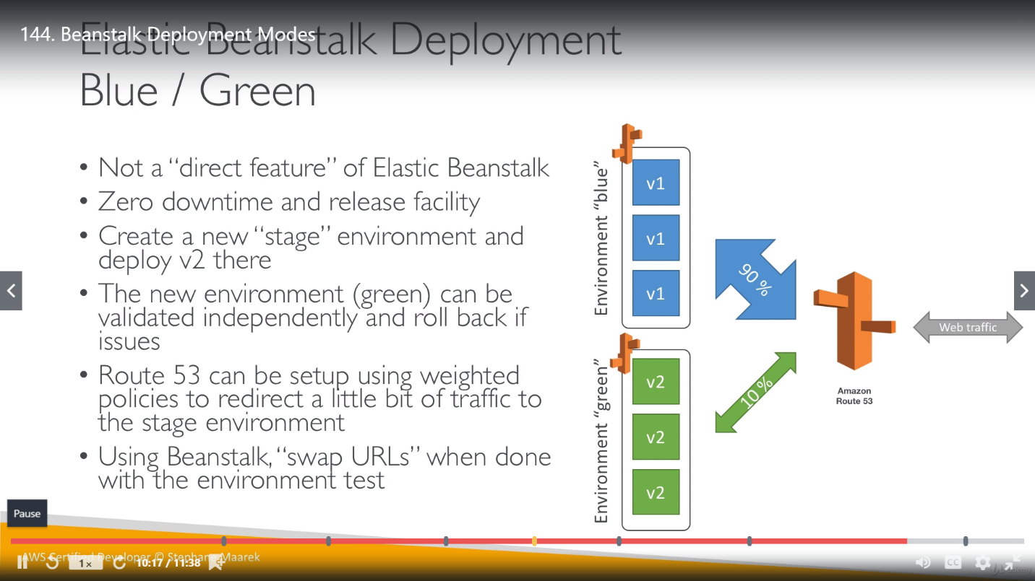

In this deployment, we have to create a new environment for same application and later we deploy all v2 instances over to it. Route-53 is used here to send small traffic (10% in this case) to green environment and once it validated that all the things are working fine it will transfer whole traffic over to it. There are so many manual steps involved in this deployment.

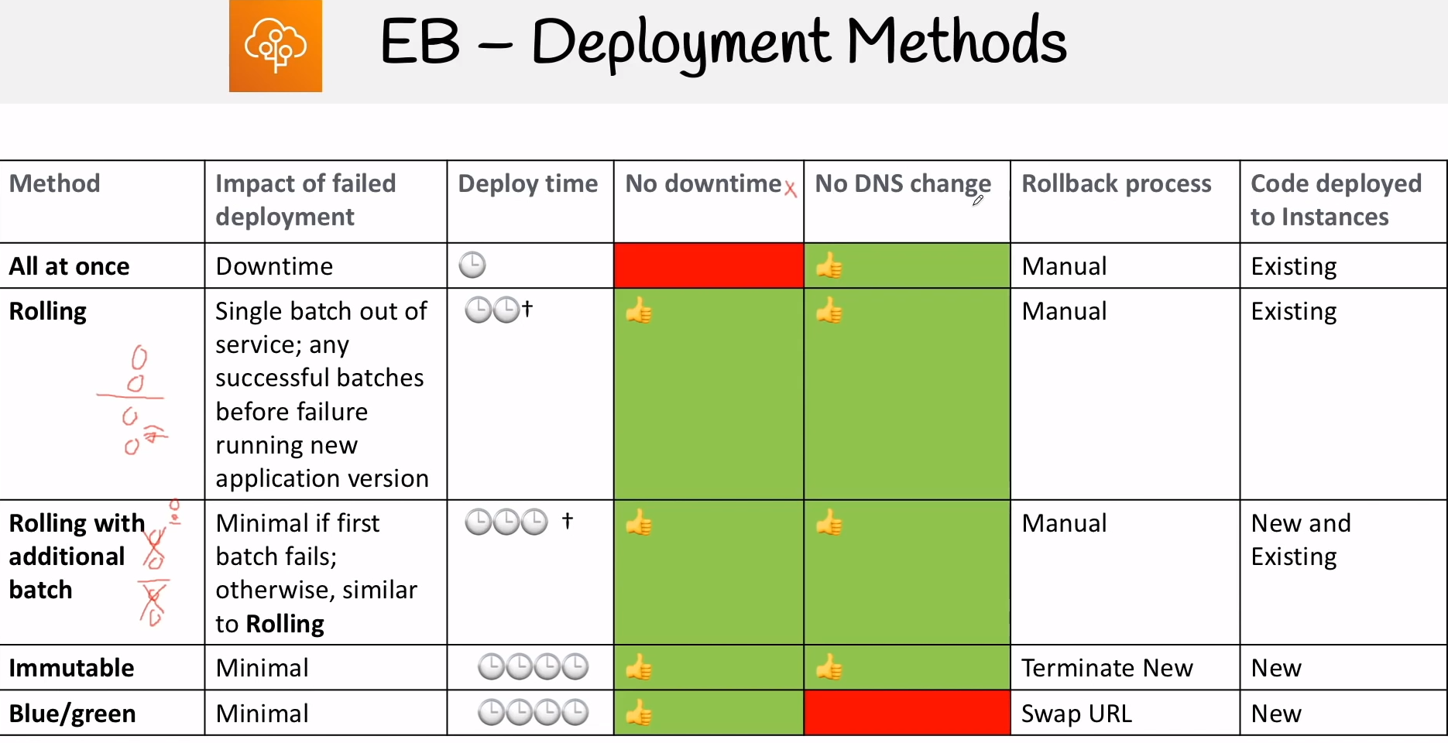

We can swap 2 environment’s URL under same application. Suppose dev env was having blue background and prod was having green env so they can be swapped with each other.

**Difference between In-place and Blue/Green Deployment:**

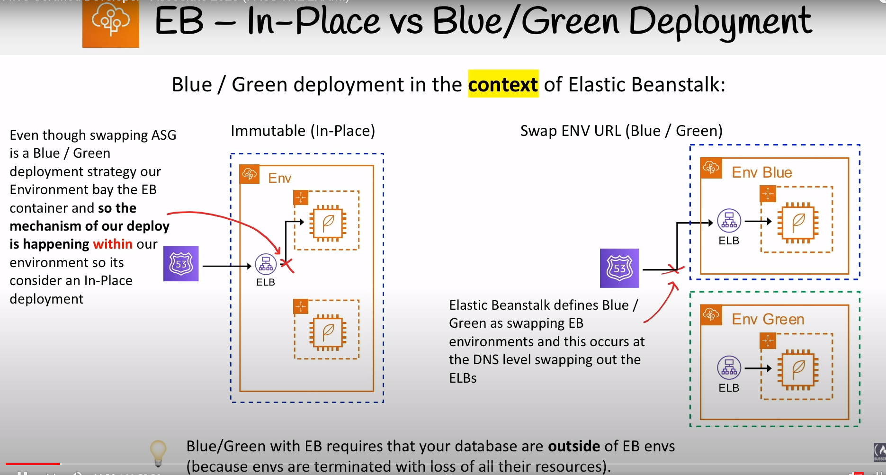

**EB Configuration file:**

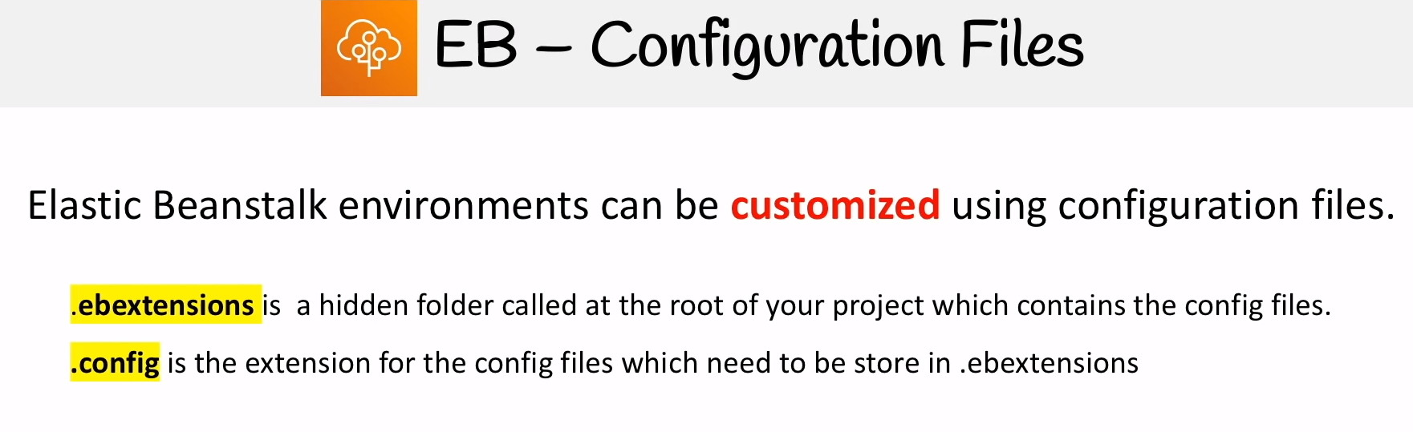

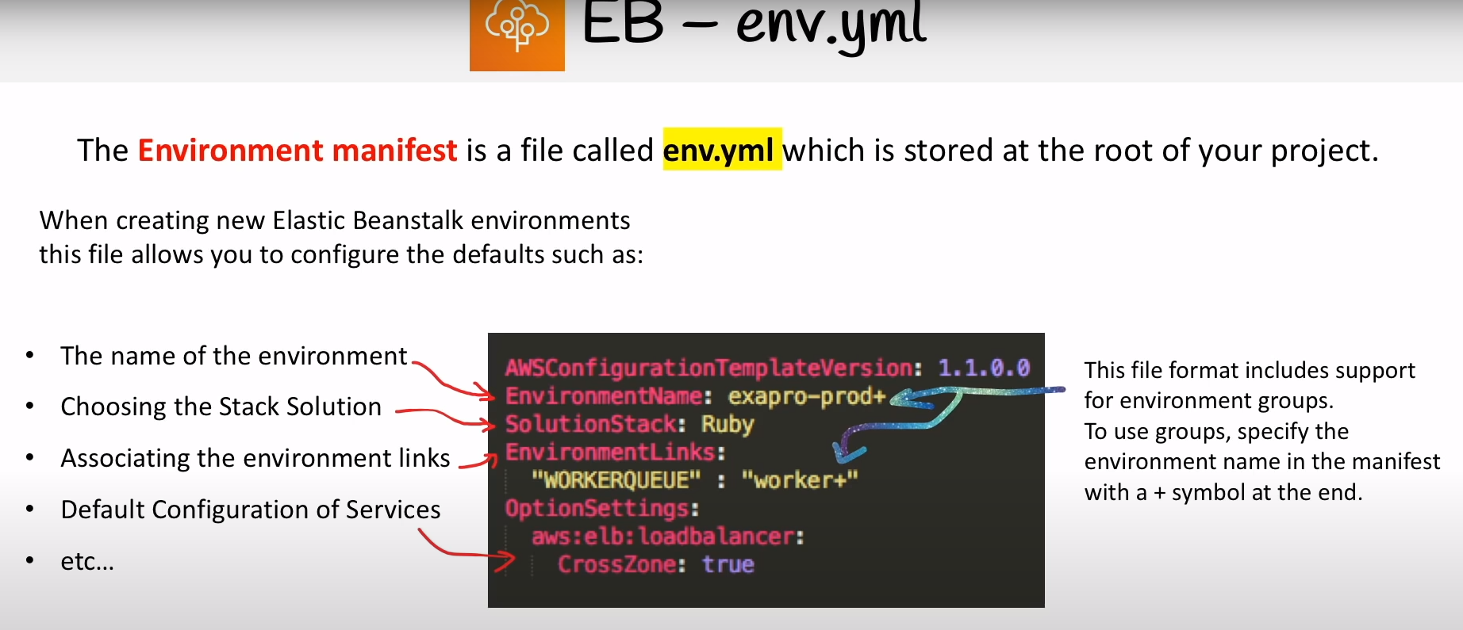

EnvironmentLinks key is used to link working and web env.

**Elastic Beanstalk CLI:**

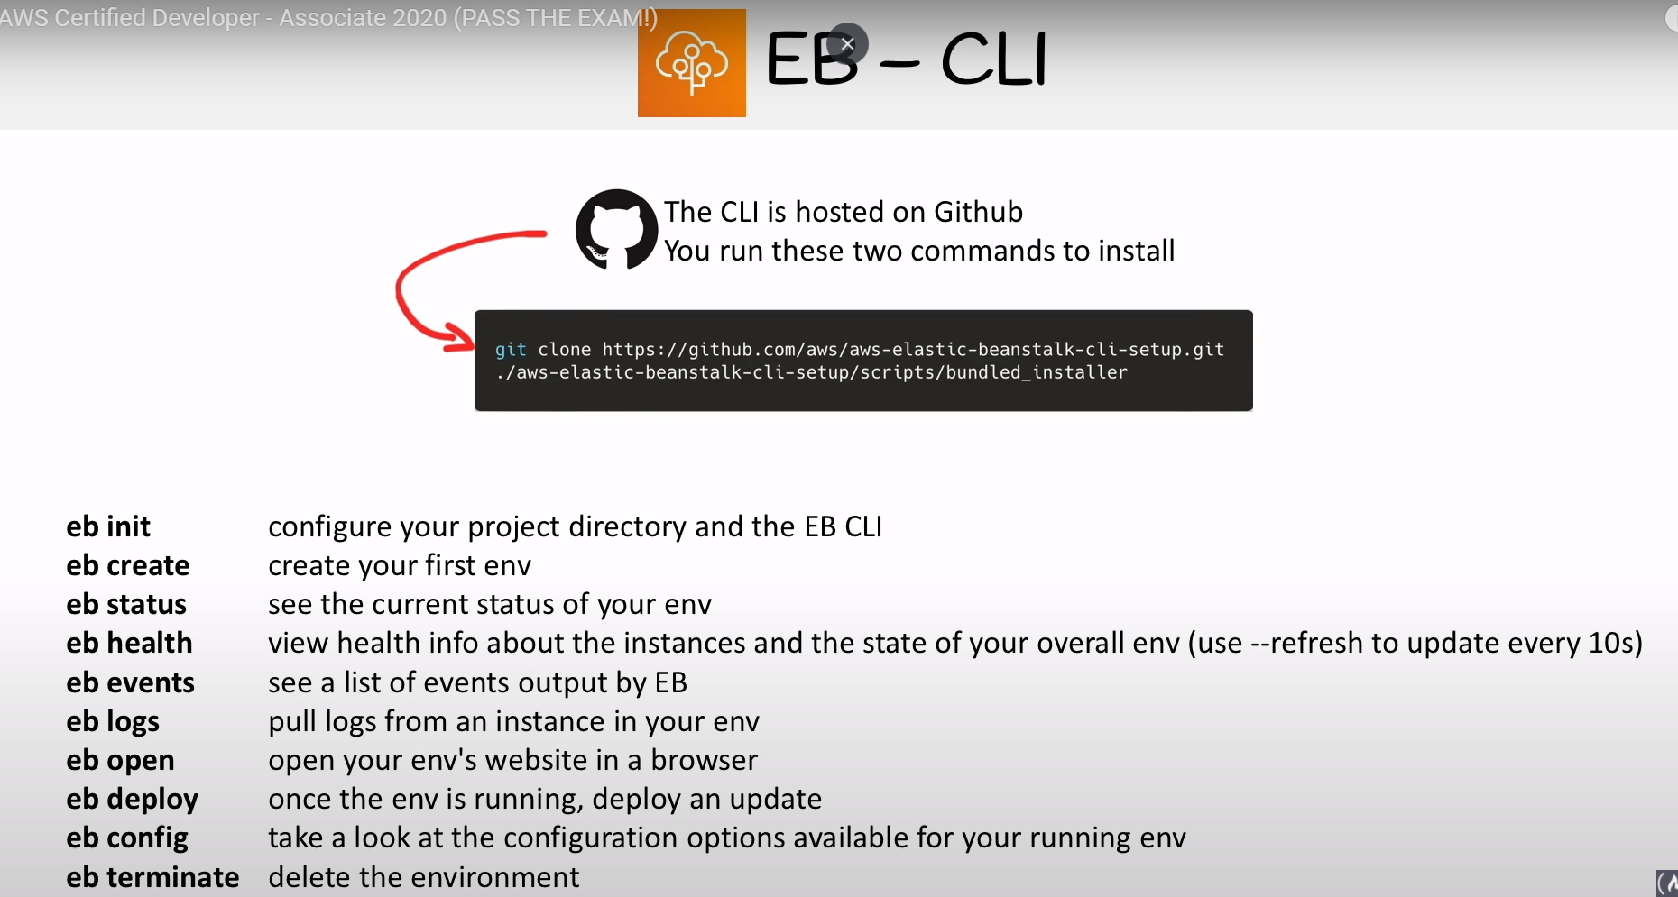

**EB Custom Image:**

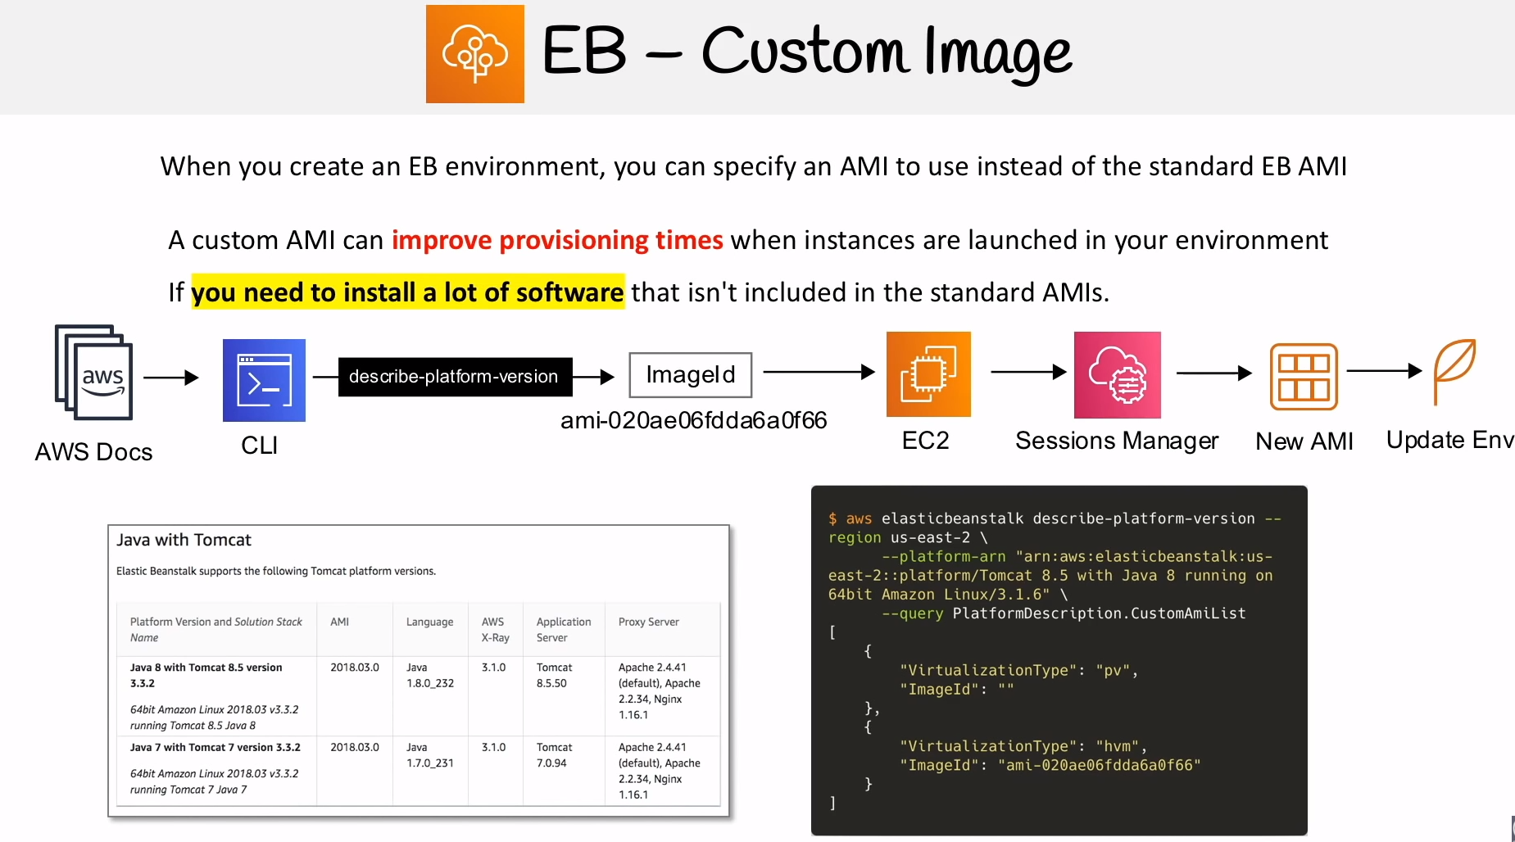

**Database for EBS:**

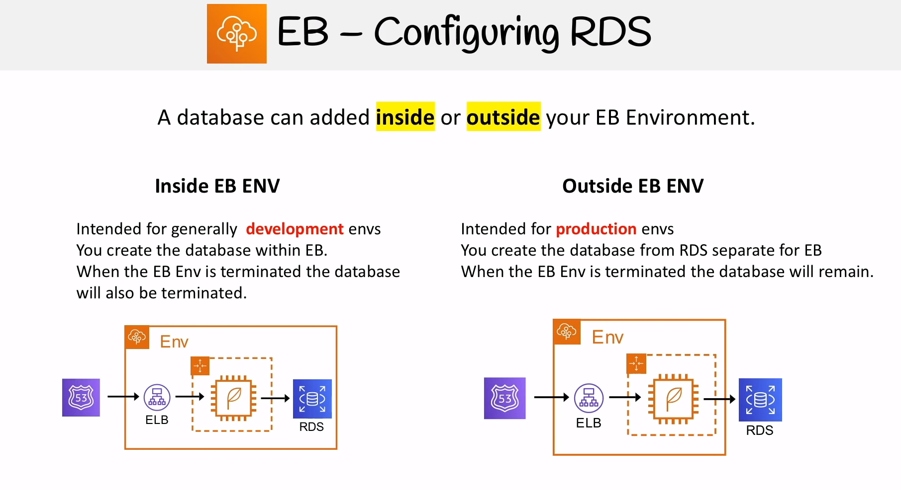

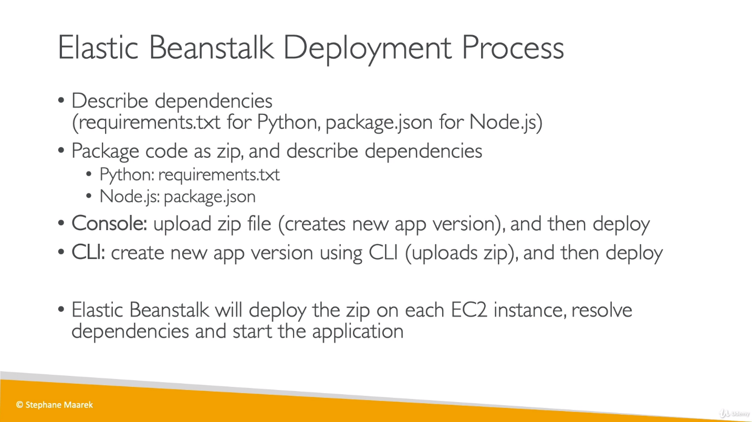

**Beanstalk Lifecycle Policy:**

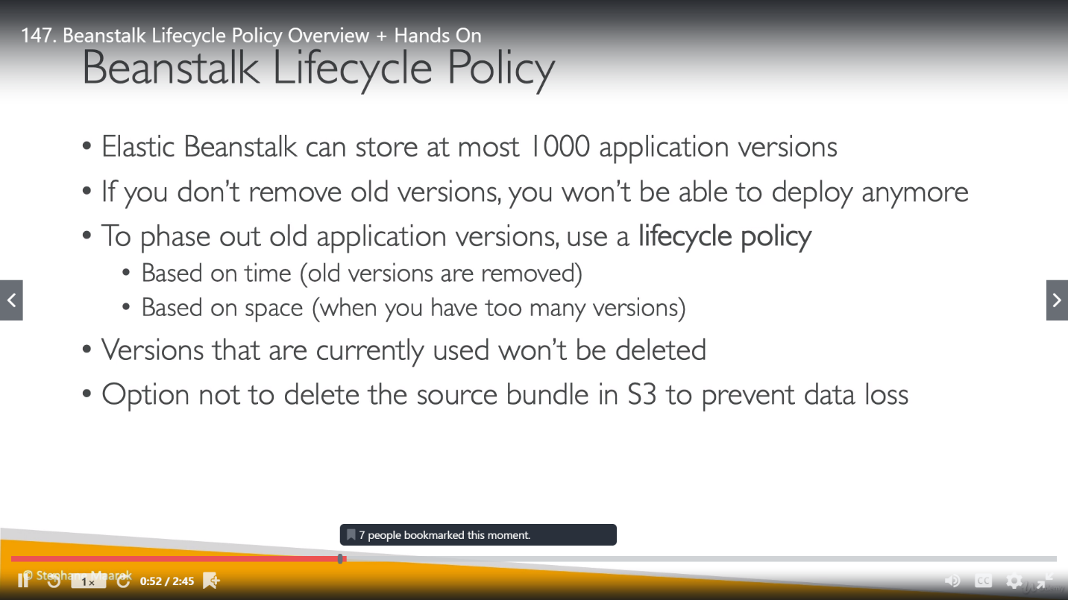

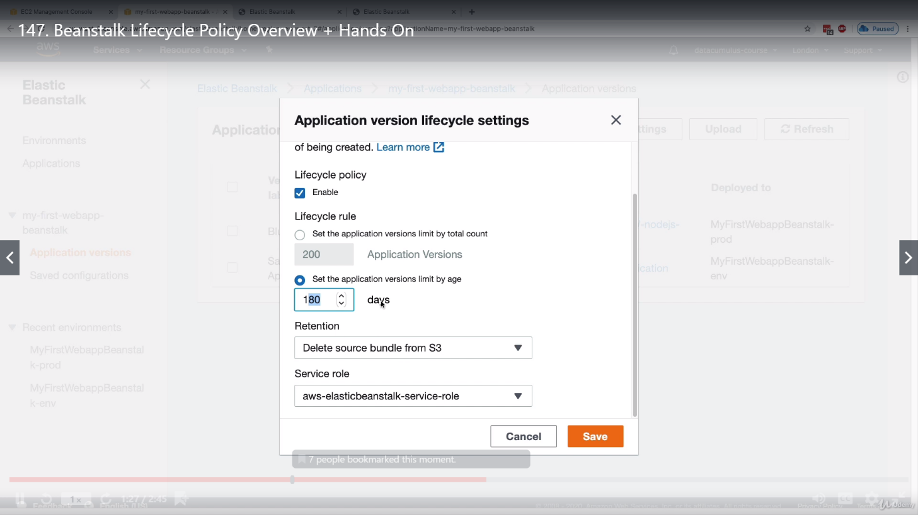

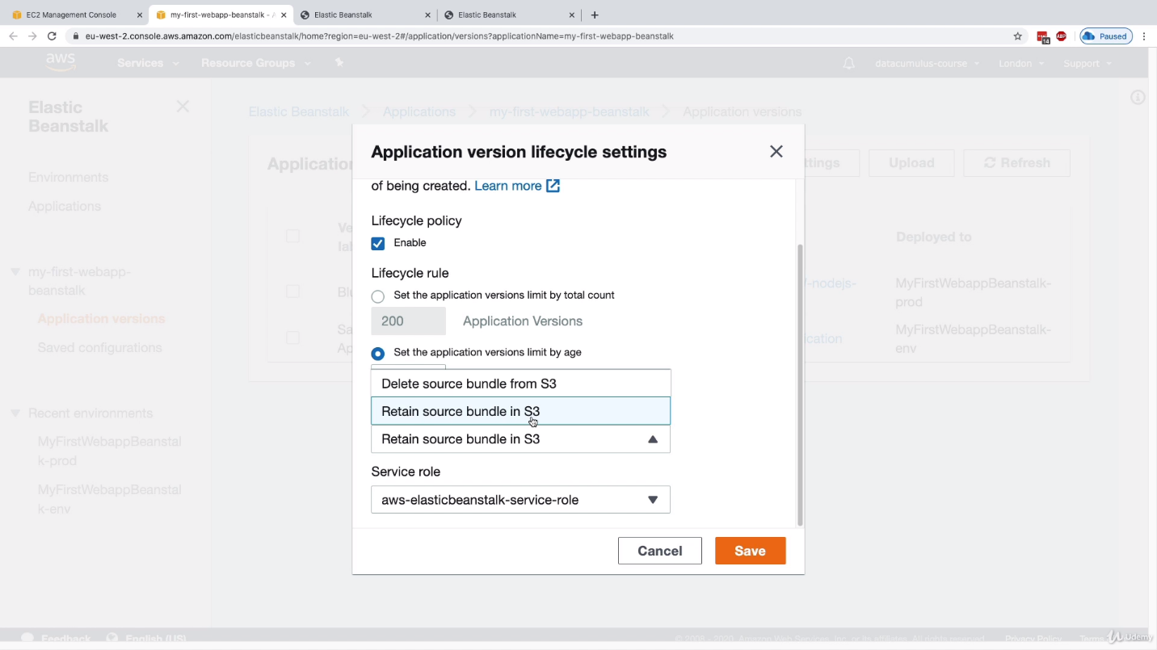

**Elastic Beanstalk Extension:** Idea is to do configurations from config files, not from UI. We have a directory, under which we have config files in YAML/JSON format but still extended with **.config**

We can do environment configuration from UI, but we can also do the same work from a config file. This config file should be under **.extensions** directory and then we can zip this and update the environment with this zip file.

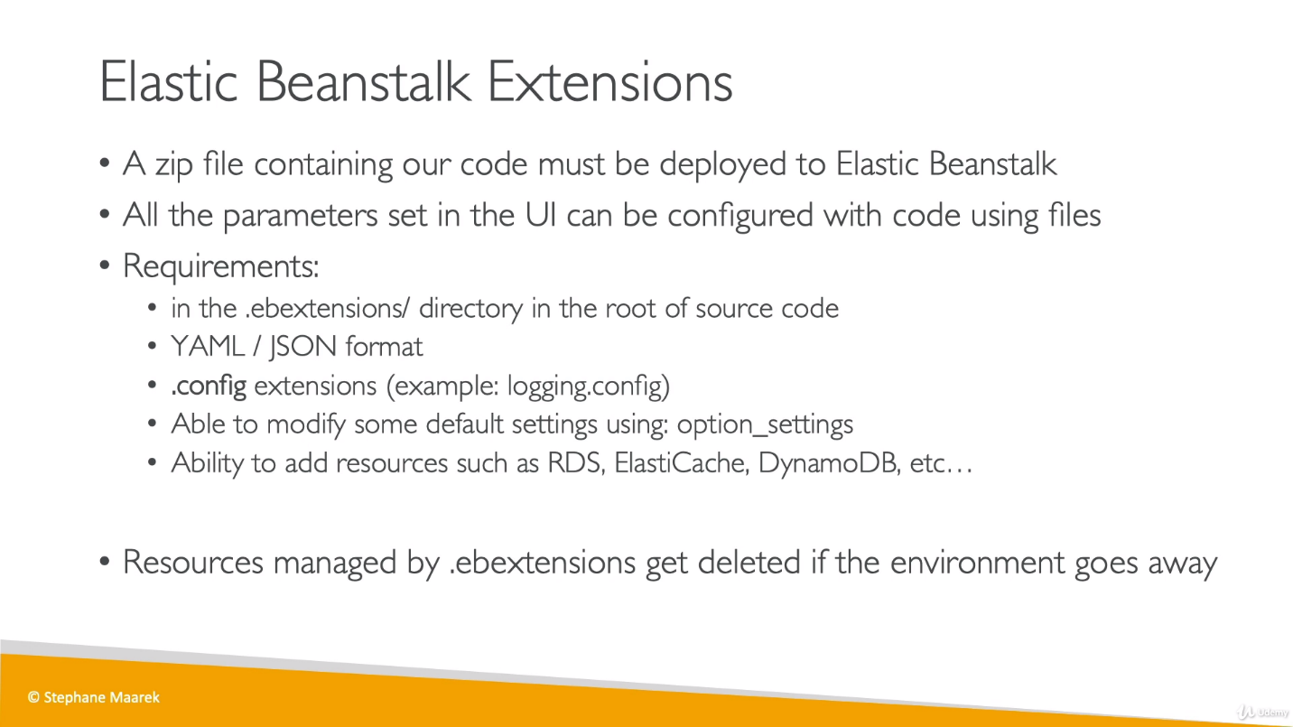

**Advanced environment customization with configuration files (.ebextensions)**

We can add AWS Elastic Beanstalk configuration files (.ebextensions) to our web application's source code to configure our environment and customize the AWS resources that it contains.

Configuration files are YAML- or JSON-formatted documents with a **.config** (code written in json or YAML, but file saved with .config) file extension that you place in a folder named .ebextensions and deploy in your application source bundle.

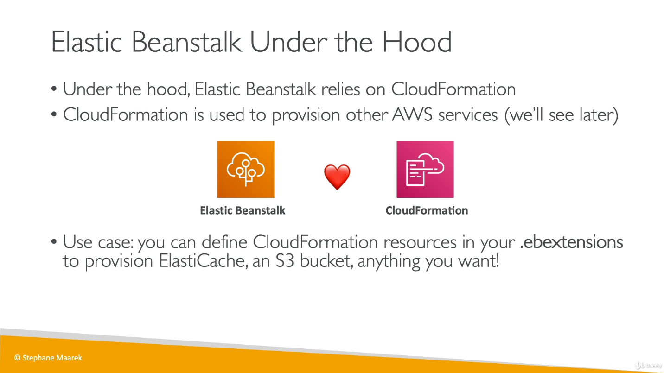

Elastic Beanstalk uses Cloud Formation templates and scripts to: 1. Create a Load Balancer and Auto Scaling Group, 2. Copy your code to S3, 3. Bootstrap an EC2 instance to Download the code from S3 and deploy it.

Cloud Formation is not as easy to use as EB, but it is much more powerful, because you can create resources other than EC2 instances, control how the cfn-init script, and etc.

**Elastic Beanstalk cloning:**

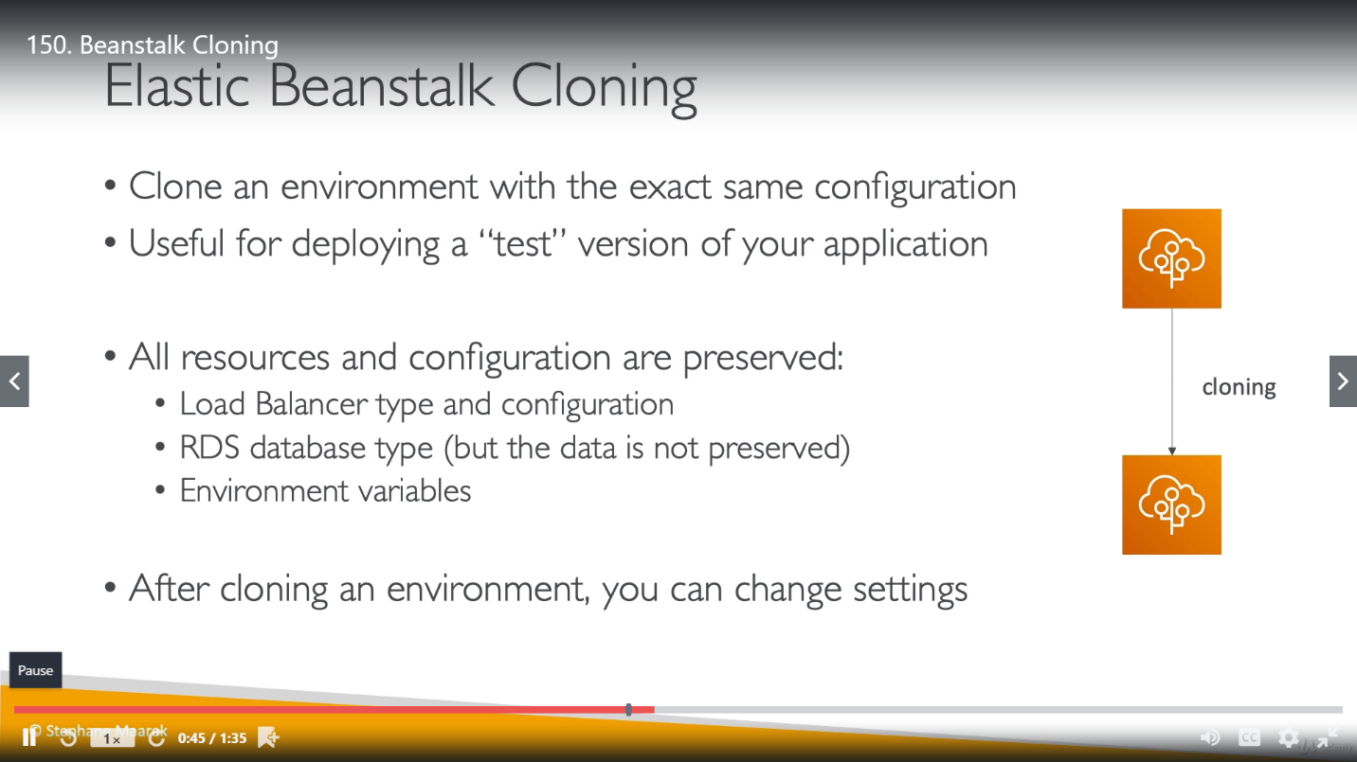

We can clone Beanstalk environment within the same application.

We can’t modify configuration while cloning an environment, but we can change settings later post cloning.

**Elastic Beanstalk Migration:**

1. **Load Balancer**

As we already know, once we chose a LB for environment, it can’t be changed but if we are in necessary to change this then we have to do below steps:

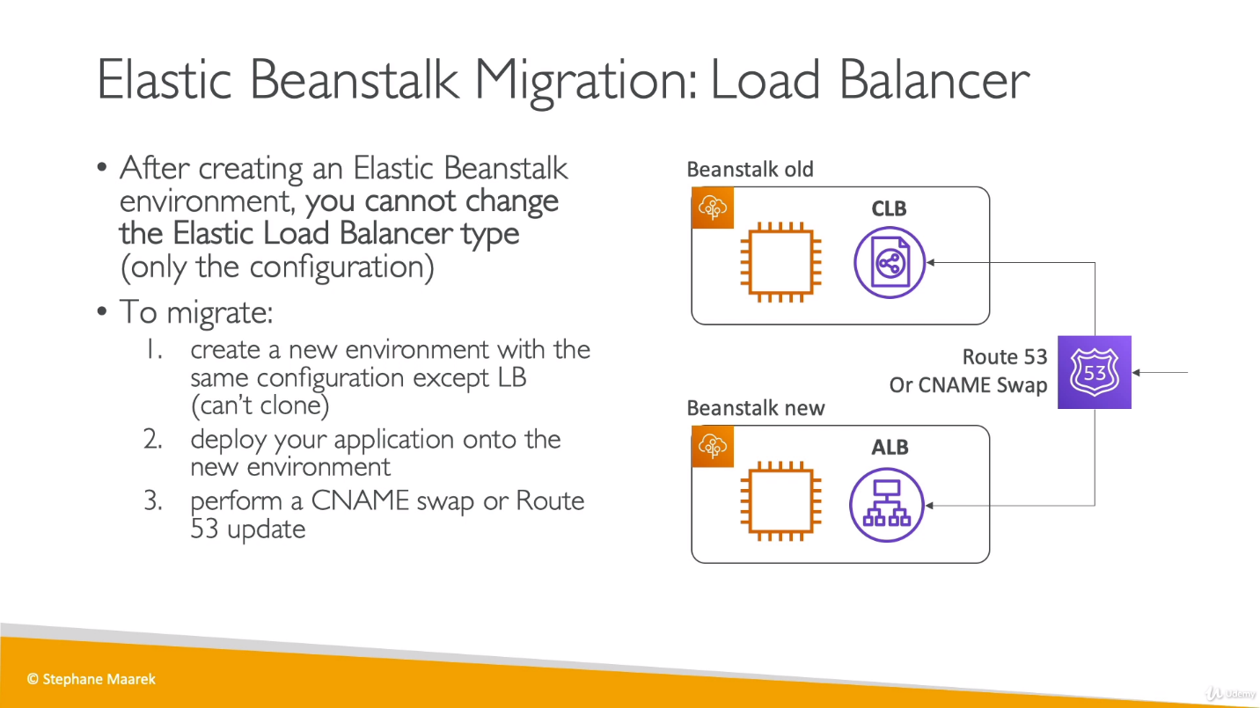

Here we are not cloning/copying anything, we are creating new env with required load balancer with old configuration and then transferring the traffic to this environment.

1. **RDS:**

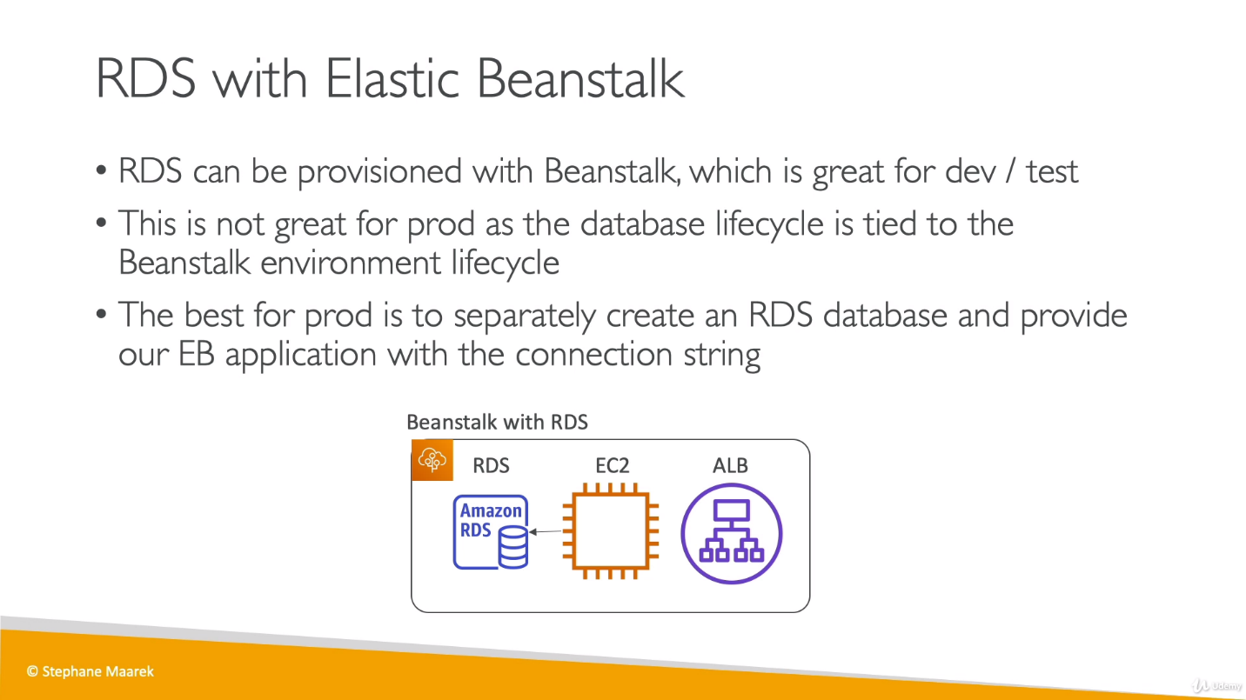

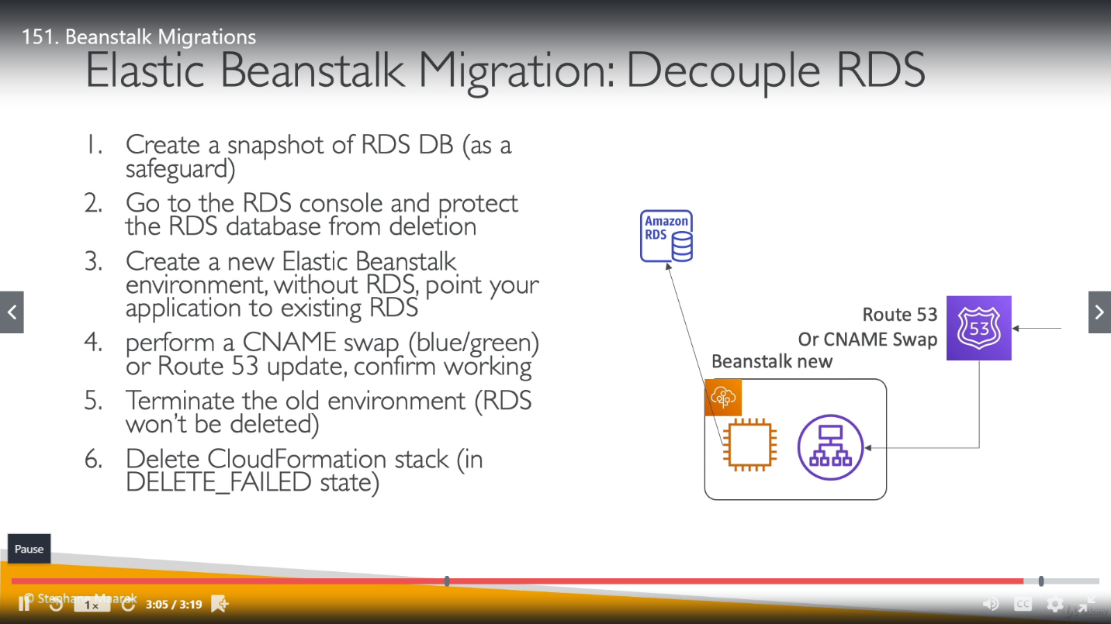

**Docker with Elastic Beanstalk:**

1. **Elastic Beanstalk with Single Docker:**

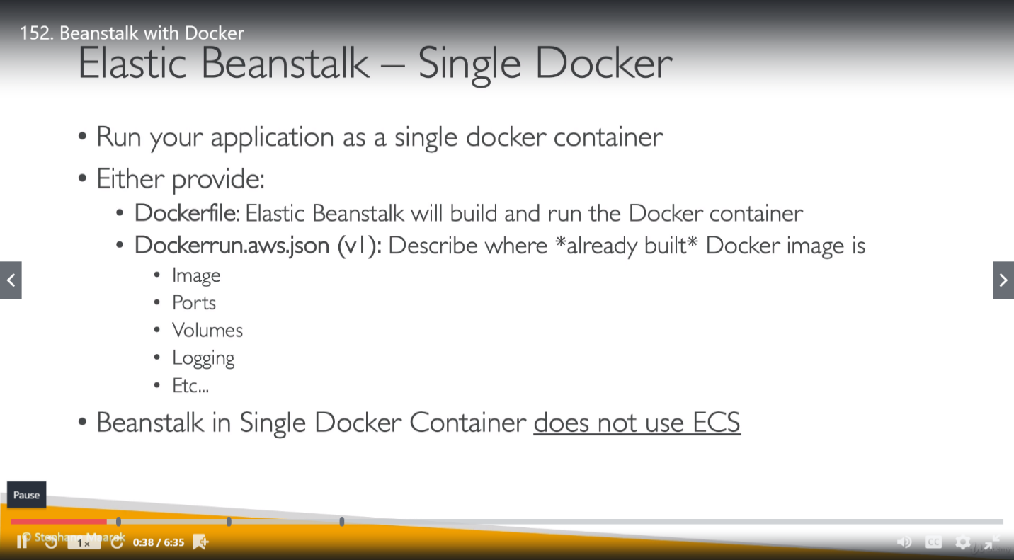

We create a new environment for Docker and choose between Single Docker or Multi Docker.

1. **Elastic Beanstalk with Multi Docker Container (using ECS):**

For any Docker environment We have a **Dockerrun.aws.json** file which contain required Task Definition for docker. We also have **.config** file under **.ebextensions** repository. So, an ECS cluster also been created for it.

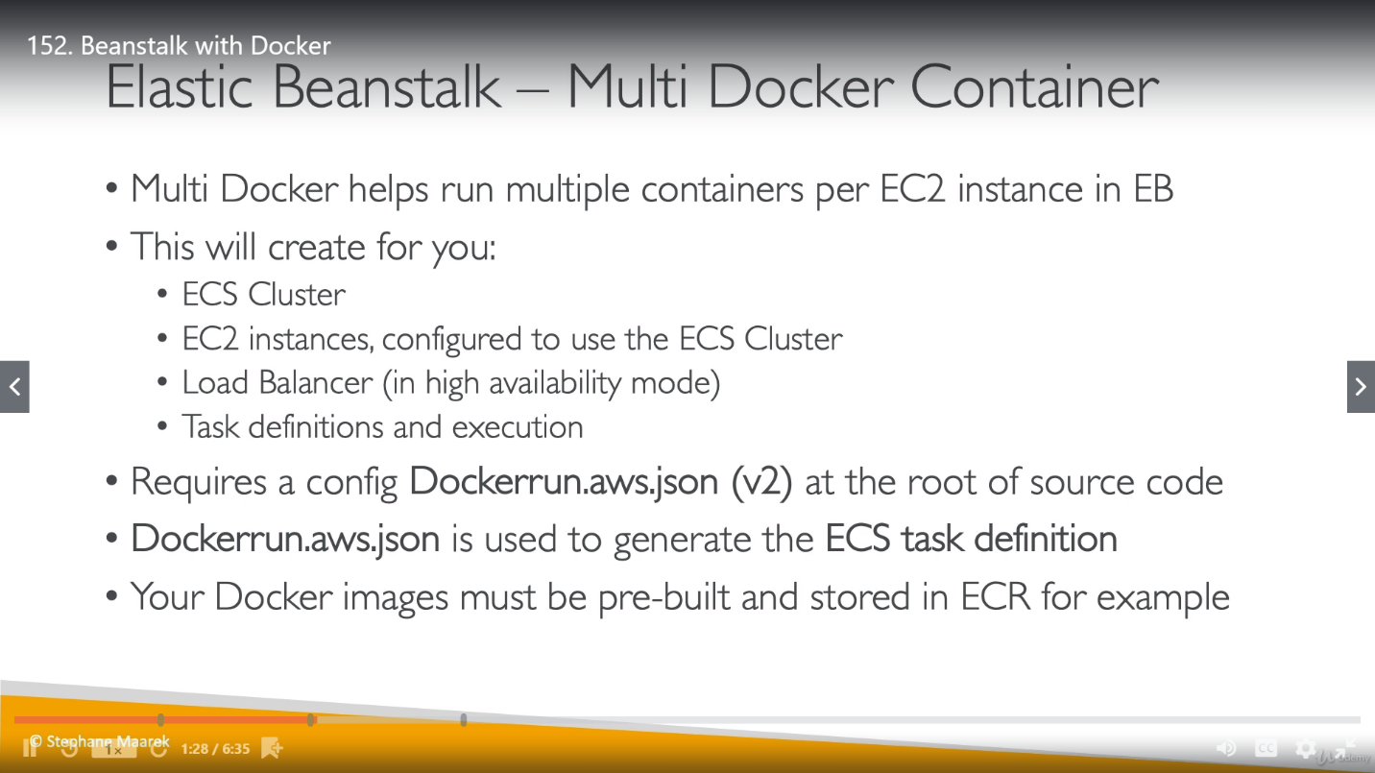

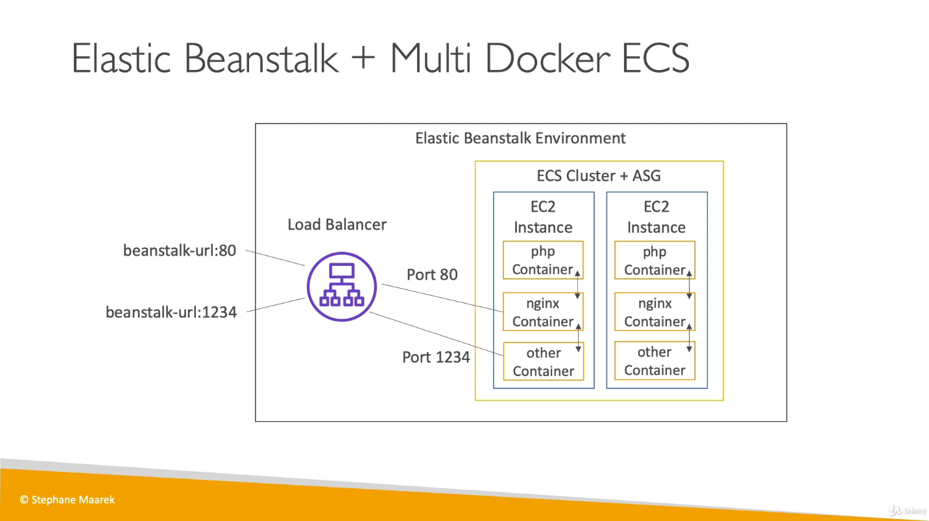

**Advance Topics:**

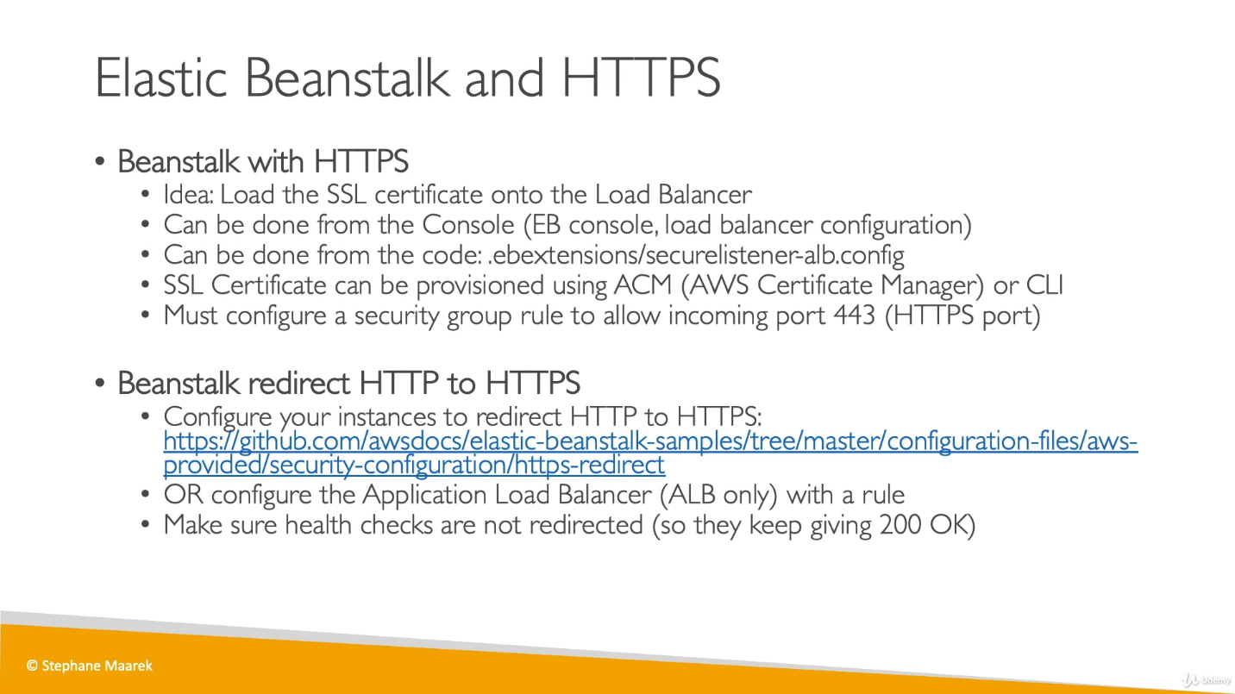

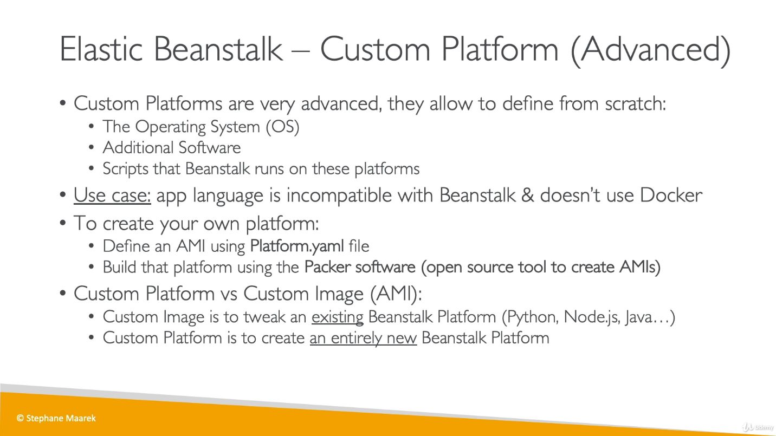

If we want to terminate all services related to an environment, we just need to change min and max capacity as 0 in that environment configuration. Related EC2 instance will be terminated automatically.

